**Comanda Express**

version-1.1.2

Author: Rodrigo Castro Albano

Date 2025/03/03

SUMMARY

I. Installation  
II. Main Menu  
III. Page Cards  
 • Card Buttons  
IV. Forms  
 • Add Product  
 • Edit Product  
 • Add Client  
 • Edit Client  
 • Add Order  
 • Edit Order  
V. Settings  
 • History  
 • Transfer Data  
 – Import a List  
 – Export a List

This guide ensures you have a comprehensive overview of Comanda Express and its key features. Should you need further assistance, please feel free to contact support.

**I. INSTALLATION**

To install the app follow the link below to the expo’s website.

https://expo.dev/accounts/rodrigocastr/projects/sales-app/builds/76204201-acf0-4cfc-b974-05143c1863dd

Once on the site, click *Install Comanda Express* and follow the on-screen instructions for your operating system. During the final step, the app will be scanned by your antivirus software to ensure its authenticity and security.

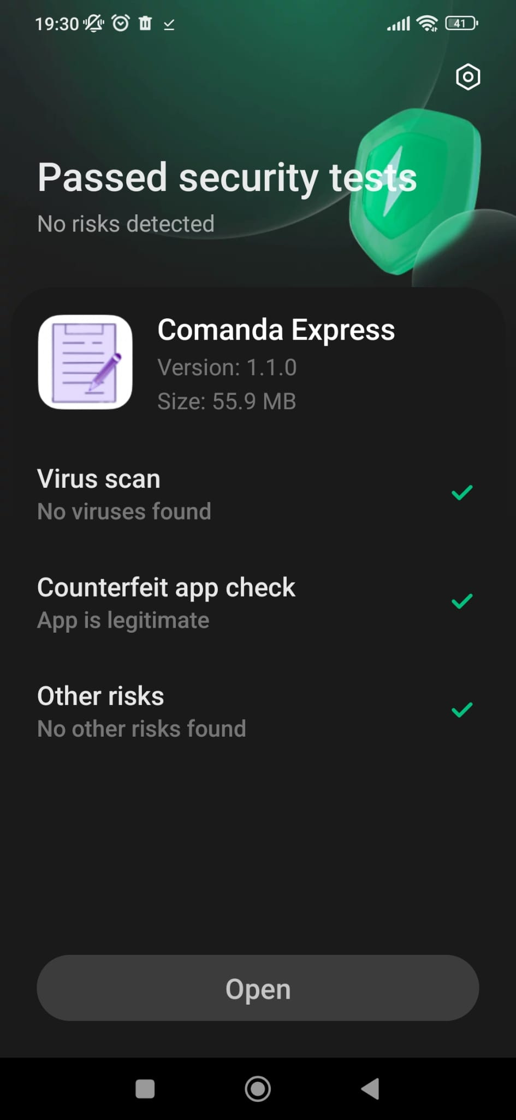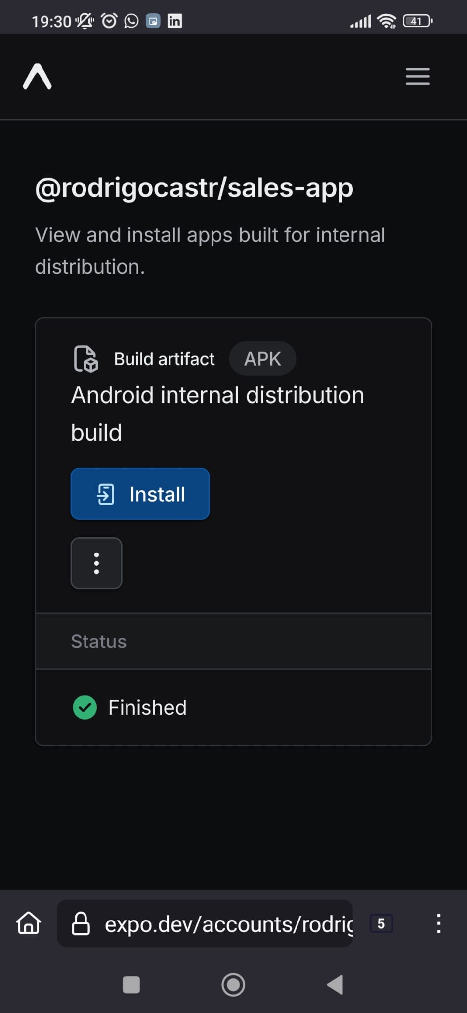

So you finally installed Comanda Express. For now, you don’t have any data in it, but don’t worry, we have tools to import new lists for your app and even export them to an external source. If you want to jump to that step go to *Settings - transfer data*.

**II. MAIN MENU**

The main navigation menu consists of 4 buttons.

* **Orders**, **Clients**, and **Products**: These buttons direct you to the respective pages displaying lists for each category.

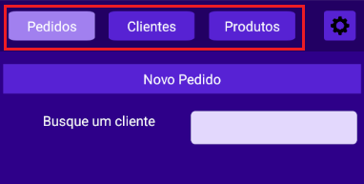

* **Settings**: This button opens the Settings menu.

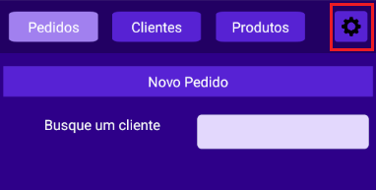

The active button will be highlighted in a different colour from the others. As shown below, the *Orders* button is selected, and an order card is displayed.

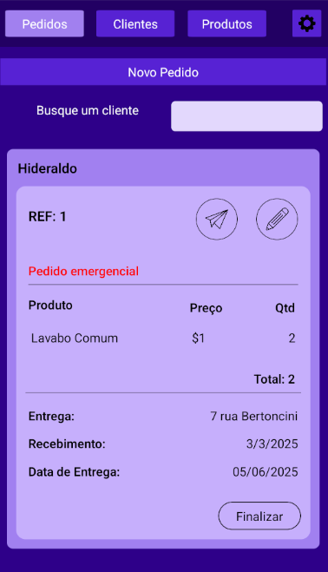

Each page includes an **Add** button to create new entries and a **Search bar** to filter and view existing records.

*To learn more about the Add button go to the *Forms Sections*

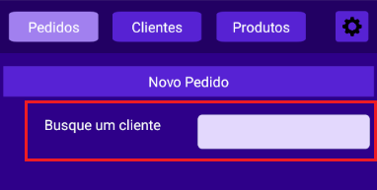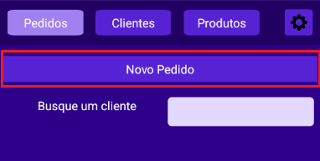

Order page - “New Order” and “Search for a client”

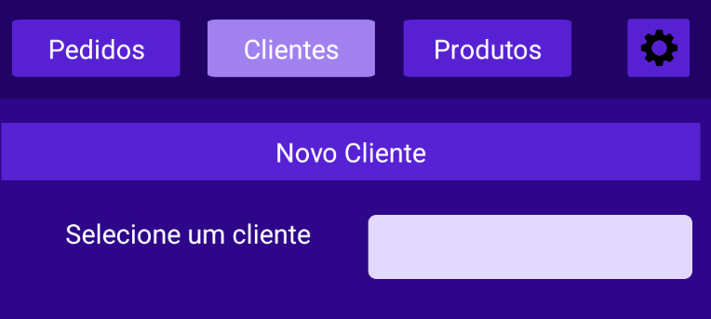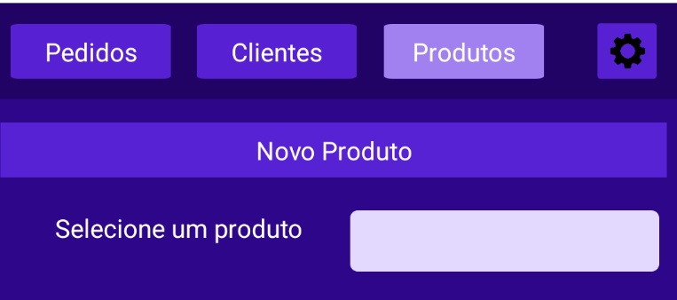

Client page - “New Client” and “Search for a client” Product page - “New Product” and “Search for a product”

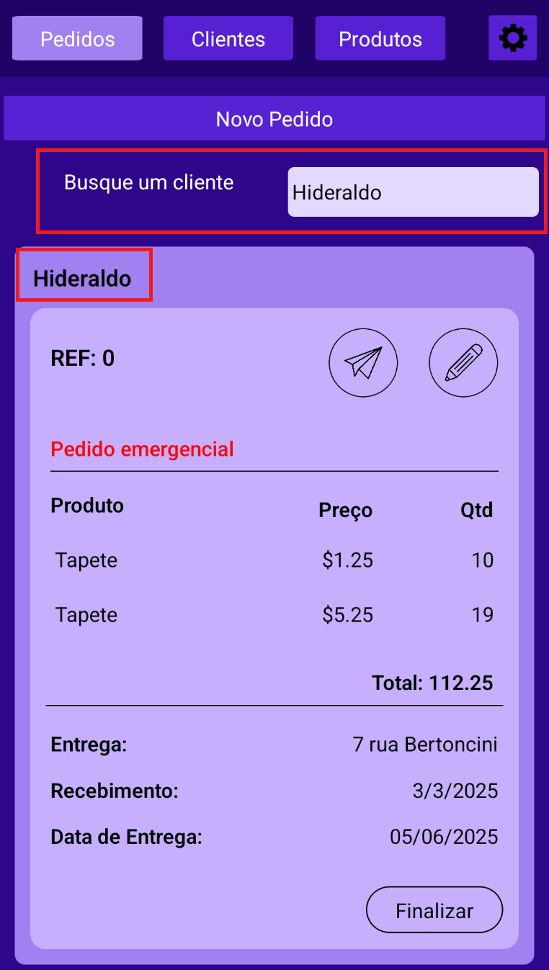

Search example

III **PAGE’S CARD**

Select a card to make it active. When activated the card buttons will change color and be enabled.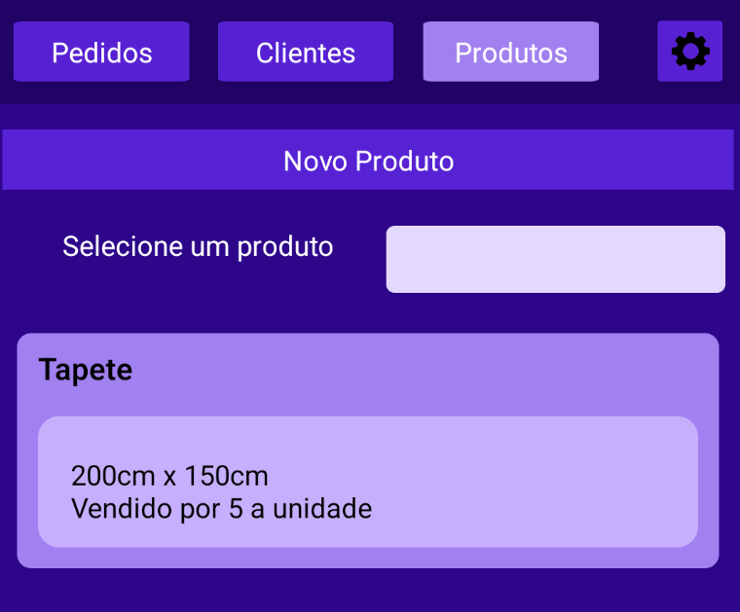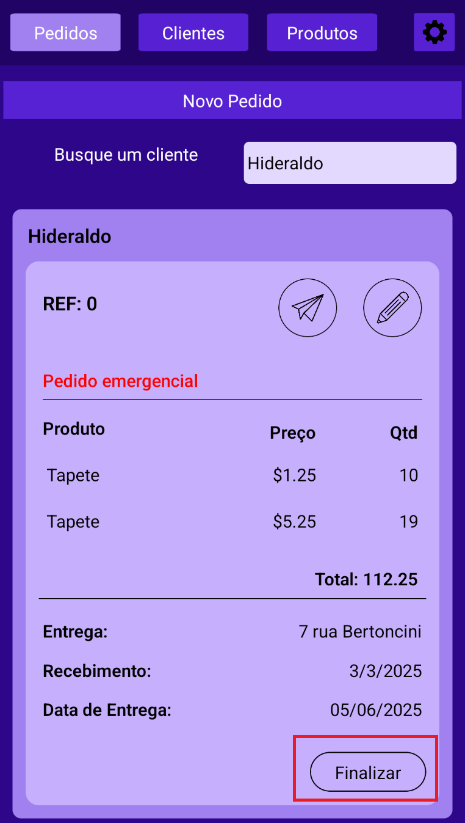

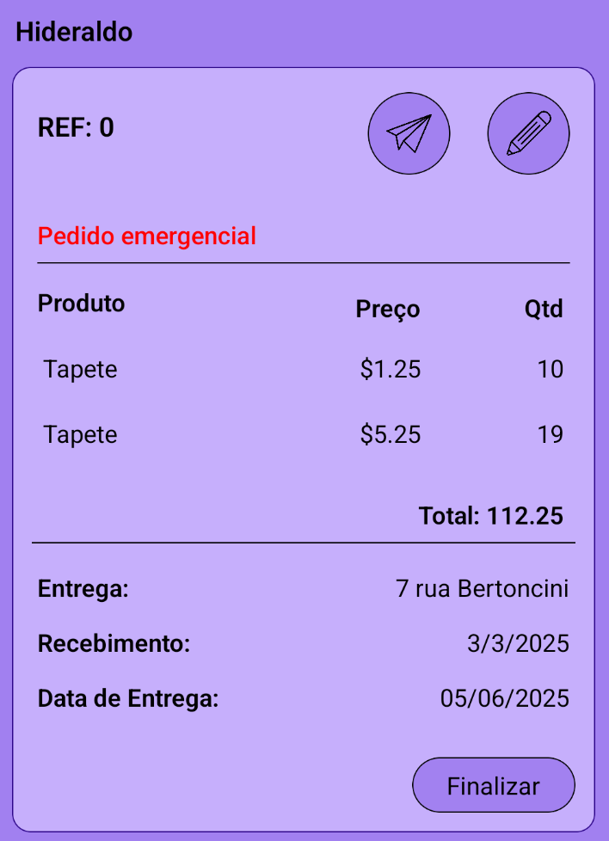

Order card activated

**CARD BUTTONS**

Each list card includes a **pencil icon** to edit the item, which will open the respective editing form.

On **Order** cards, you will find two additional features:

* **Paper plane icon**: Use this to send the order details via WhatsApp.
* **Finish button**: Mark the order as completed. Finished orders can be reviewed under the *History* section. See the *Settings - History* for more details.

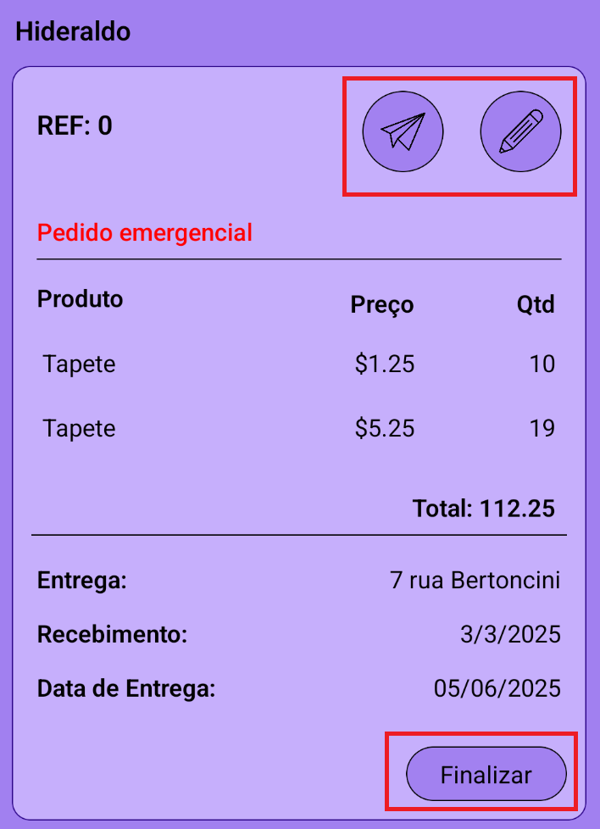

**IV FORMS**

When you click the *Add button* one of these Forms will showup:

**ADD PRODUCT**

- The **Name** field is mandatory.

- You may add a product description (e.g., size, regular price).

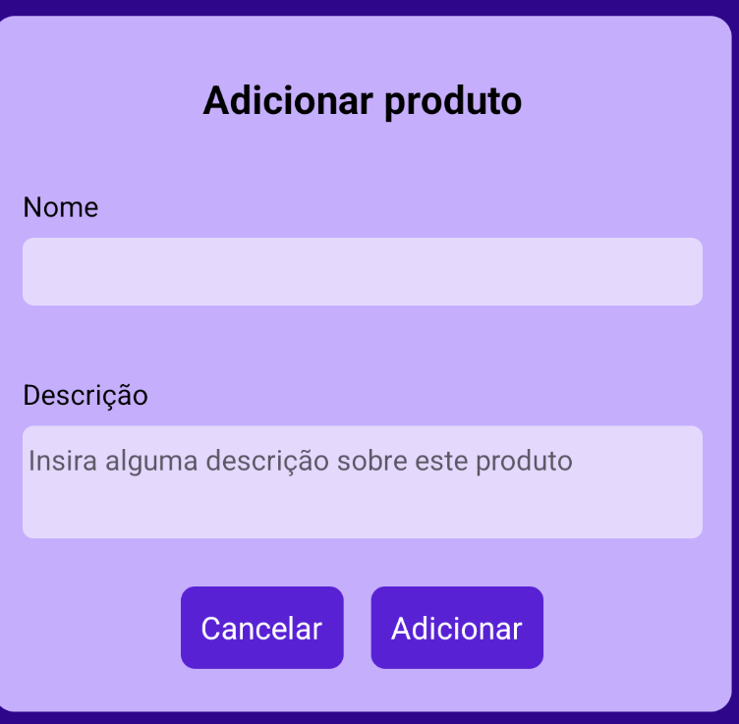

To save the product, click *Adicionar* (Add). To cancel, click *Cancelar*.

**EDIT PRODUCT**

The product's **Name** will appear at the top of the form.

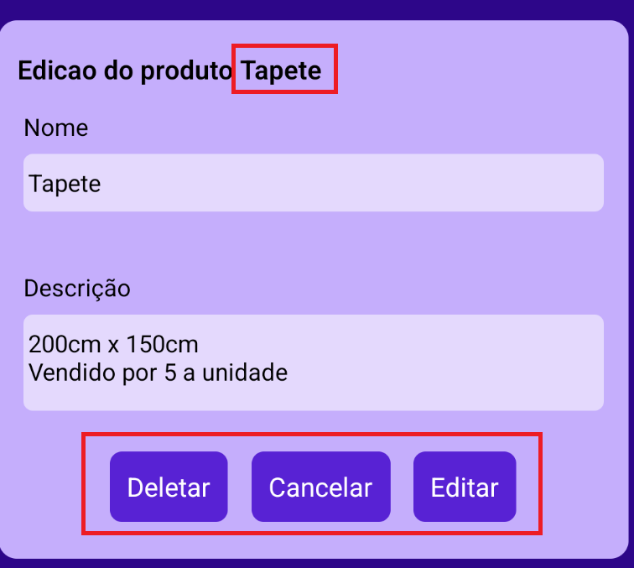

To save changes, click *Editar* (Edit). To cancel, click *Cancelar*. You can also delete the product by clicking *Deletar* (Delete).

**ADD CLIENT**

- **Name**, **Contact**, **Email**, and **Address** fields are mandatory;

- Optionally, you can add a note for the client.

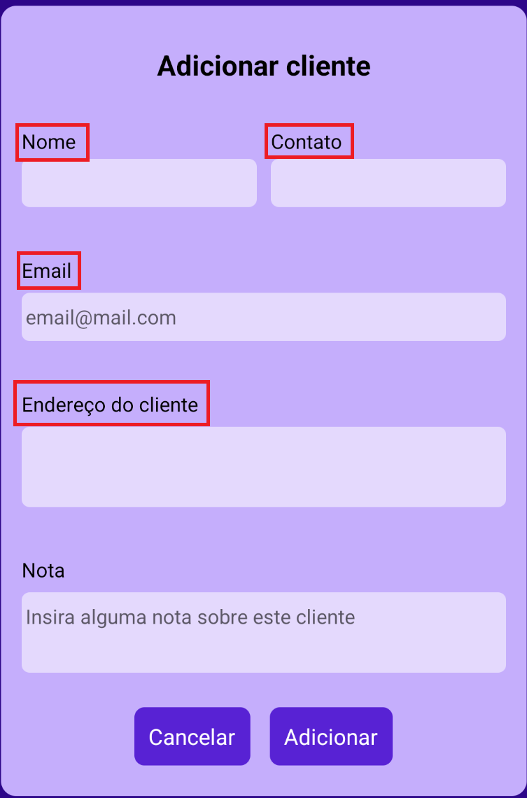

To save the new client, click *Adicionar* (Add). To cancel, click *Cancelar*.

**EDIT CLIENT**

The client’s **Name** will appear at the top of the form.

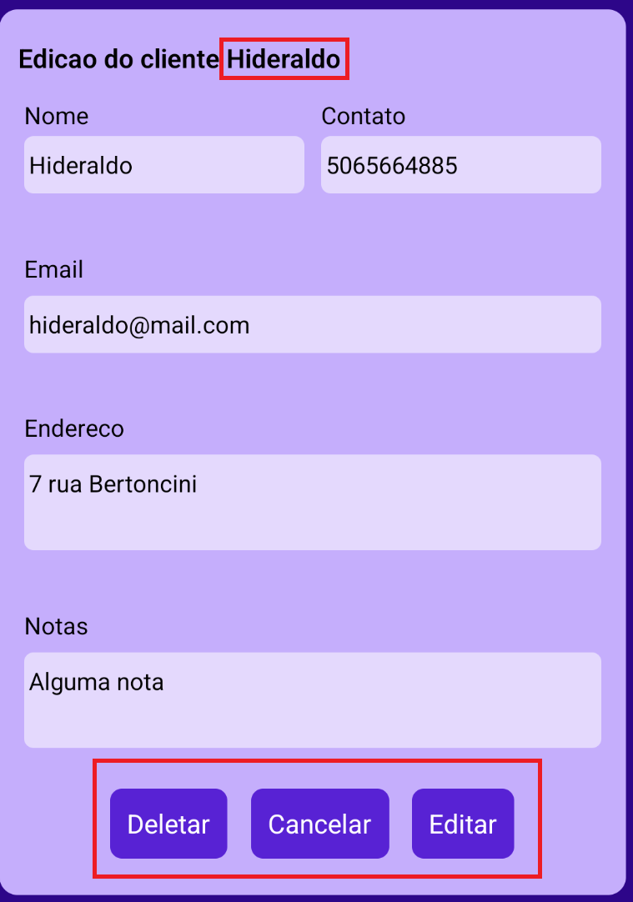

To save changes, click *Editar* (Edit). To cancel, click *Cancelar*. You can also delete the client by clicking *Deletar* (Delete).

**ADD ORDER**

- **Client**, **Product**, **Amount**, **Price**, **Address**, and **Date** fields are.

- You may add a product description (e.g., delivery instructions or discounts).

For the **Client** field, type the client’s name to bring up matching options in a dropdown. Do the same for the **Product** field:

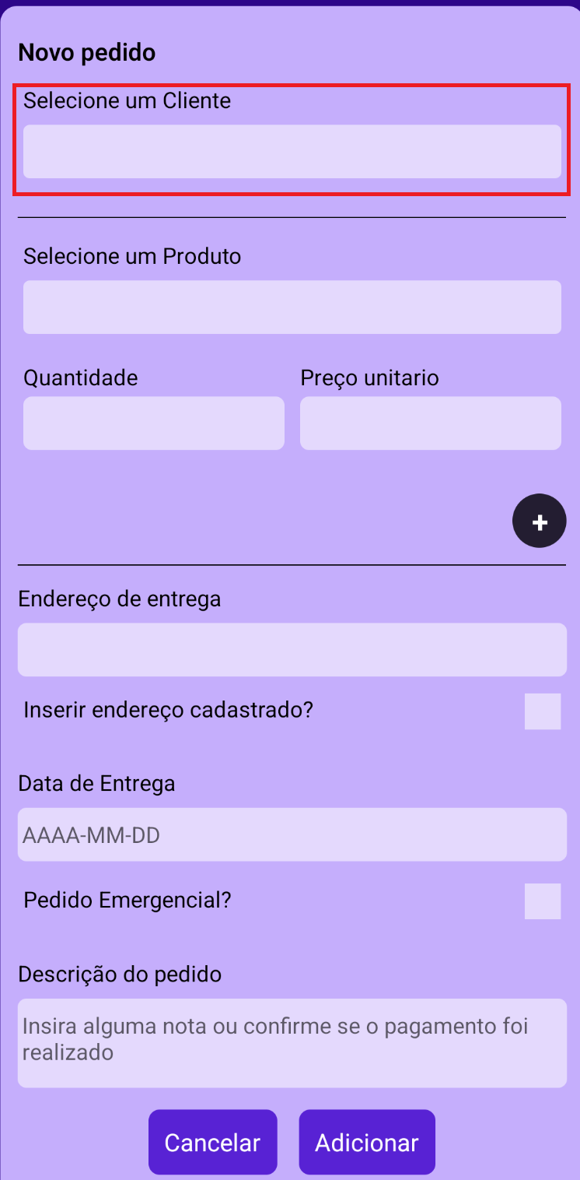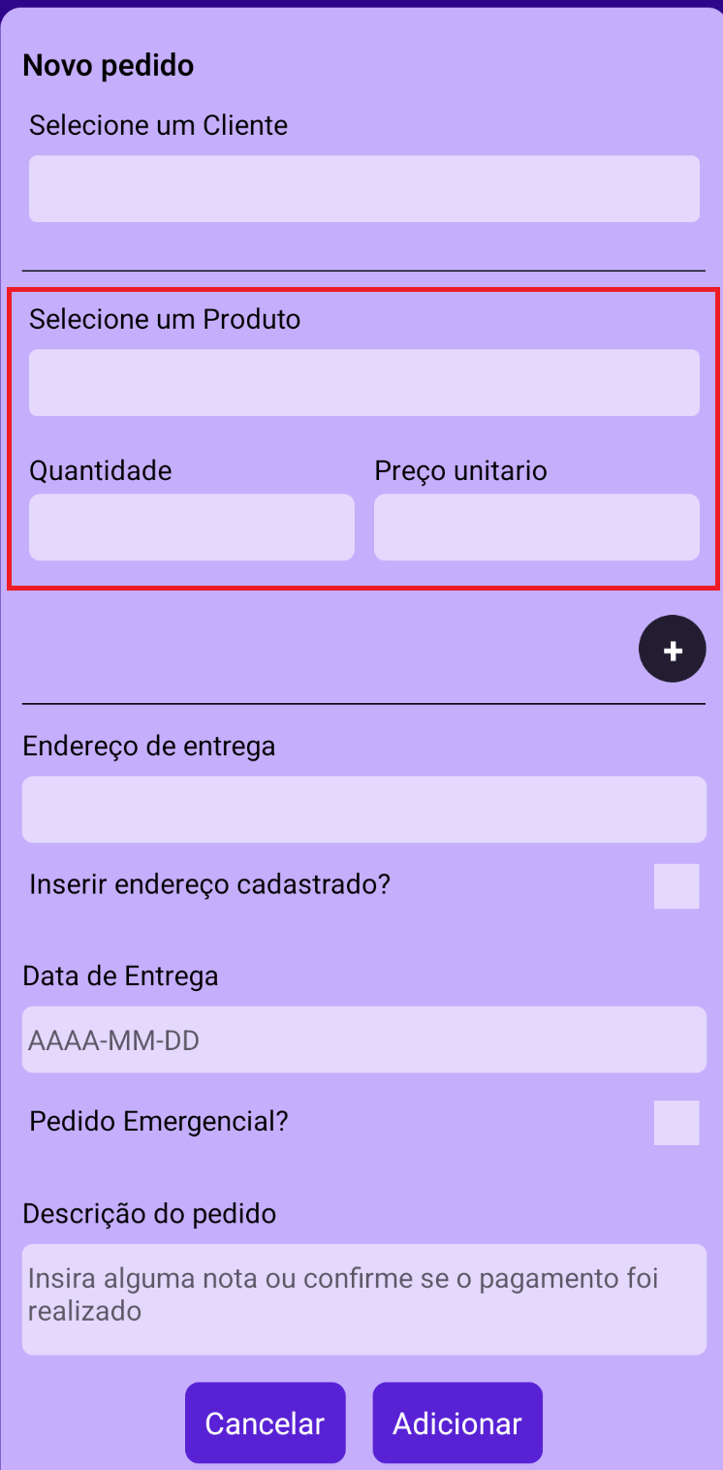

After selecting the product, you can add additional products by clicking the **+** button. To remove a product, click the **-** button.

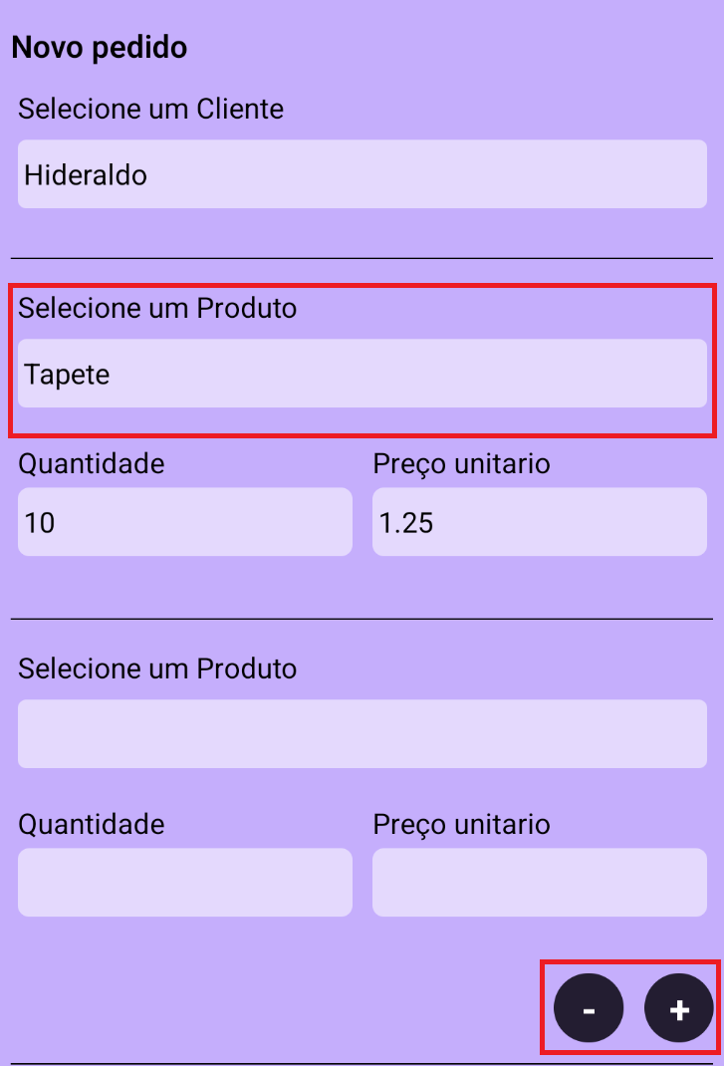

After setting up the products you can write the address to which this order will be delivered. You can press the checkbox below the input to automatically insert the client’s address:

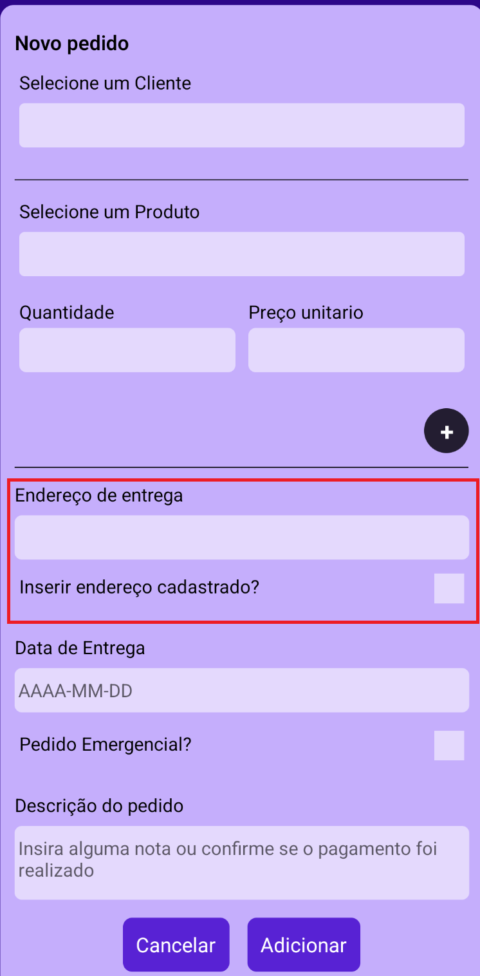

Then, choose the date this order needs to be delivered. If this order is an emergency you can press the “Emergency Order” checkbox.

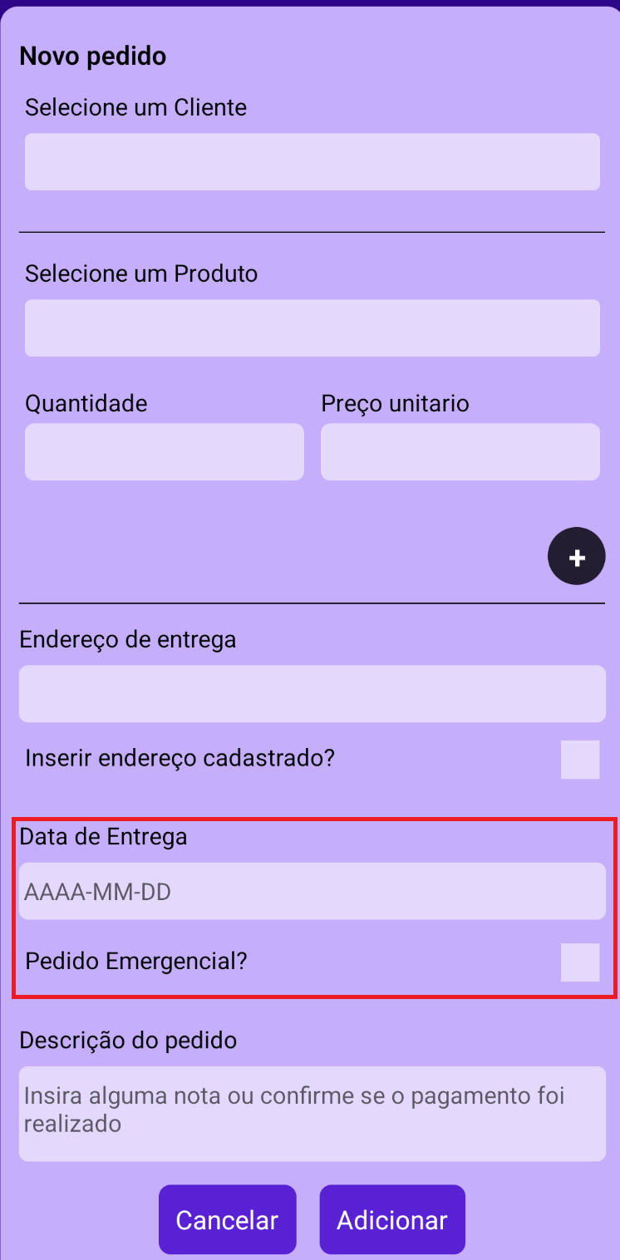

To save the order, click *Adicionar* (Add). To cancel, click *Cancelar*.

**EDIT ORDER**

The **Order ID** and **Client Name** will appear at the top of the form.

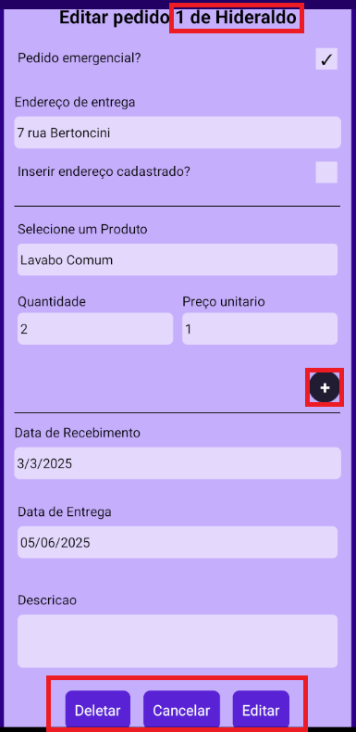

You can modify the order by using the **+** and **-** buttons to adjust the products and quantities.

To save the changes, click *Editar* (Edit). To cancel, click *Cancelar*. You can also delete the order by clicking *Deletar* (Delete).

**V SETTINGS**

**HISTORY**

Click the **History** button to view completed orders.

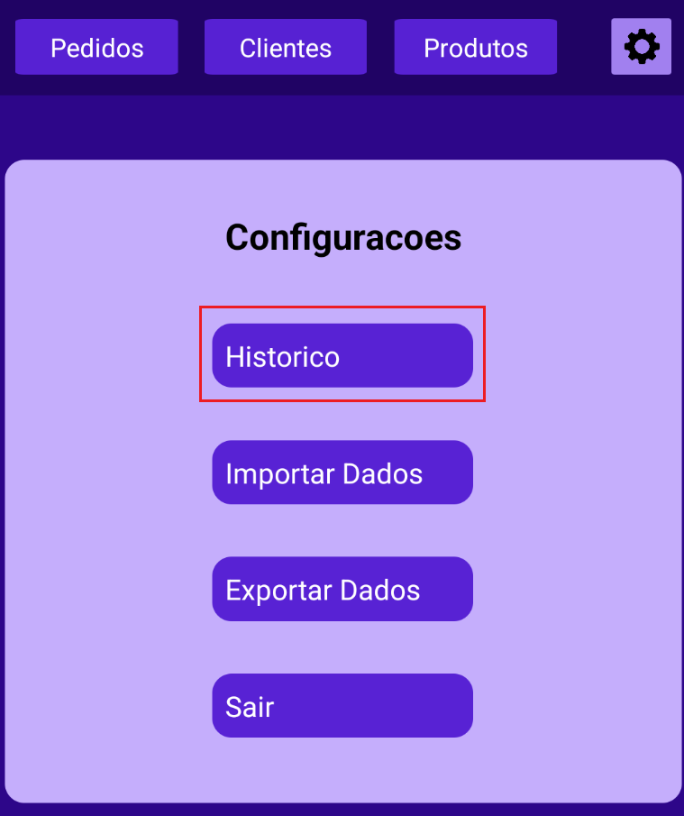

You can filter the history by client by typing the client’s name into the **Search bar**. Each history card displays order details, along with a button to reactivate the order. Simply select the order to enable the *Reactivate* button.

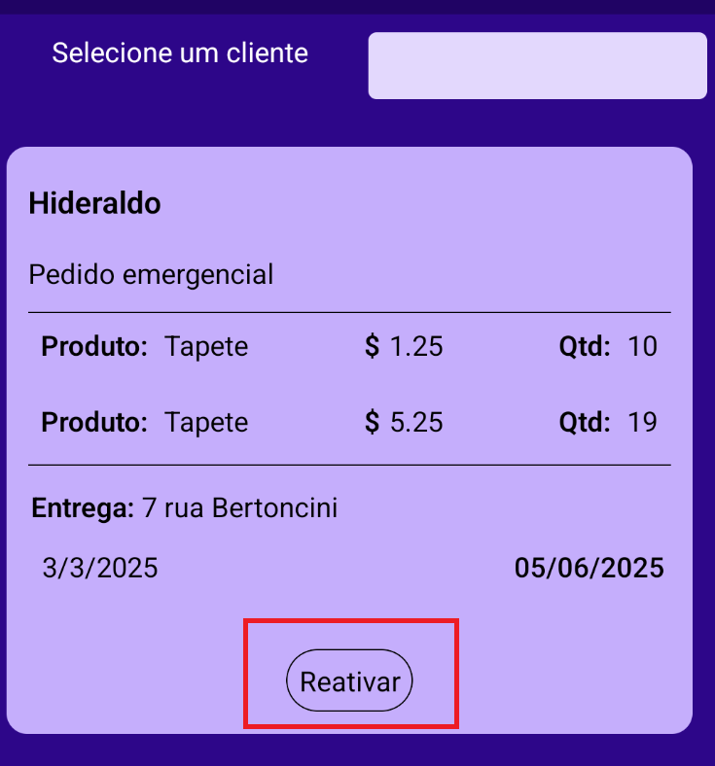

**TRANSFER DATA**

This section allows you to import or export lists:

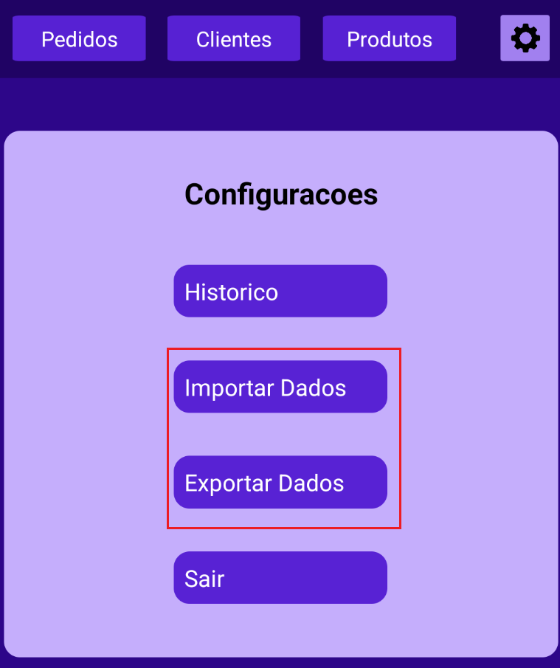

**IMPORT A LIST**

To import data, click **Importar Dados**. Enter a JSON array into the input field and click **Salvar** (Save).

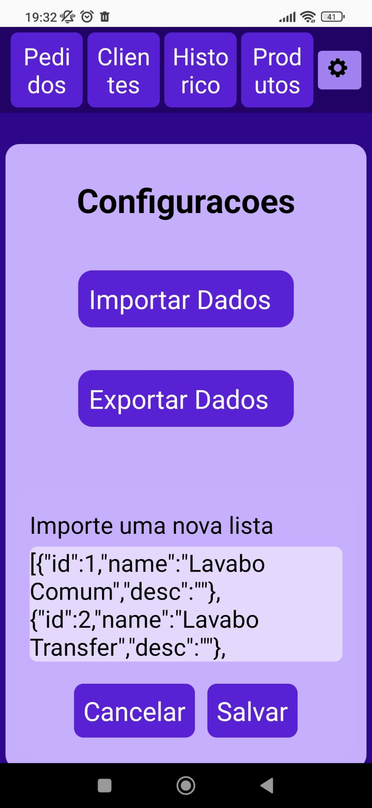

Example of a **Client List**:

[{"name":"Hideraldo","email":"exemplo@mail.com","address":"Rua Antonio Bertoncini, 1135","tel":"(99) 9856-9999","notes":"Loja nova em abril","orders":[{"id":0,"product":["Lavabo Comum","Lavabo Transfer"],"amount":[10,20],"price":[1.95,3.2],"eo":false,"desc":"Pagamento não realizado. Passar semana que vem para cobrar","receiveDate":"3/24/2022","deliveryDate":"5/4/2024","deliveryAddress":"999 Rua Tal, Cidade Tal","isActive":true,"warehouse":false},{"id":1,"product":["Copa Nova","Tapete Metrao"],"amount":[150,33],"price":[6.2,12.5],"eo":false,"desc":"Pagamento realizado","receiveDate":"3/24/2022","deliveryDate":"12/31/2025","deliveryAddress":"1853 Nereu Ramos, Mato Alto","isActive":true,"warehouse":false}]}]

Example of a **Product List**:

[{"id":1,"name":"Lavabo Comum","desc":""},{"id":2,"name":"Lavabo Transfer","desc":""},{"id":3,"name":"Copa Nova","desc":""},{"id":4,"name":"Tapete Metrao","desc":"200cm x 50cm"}]

Upon importing, you will be prompted to select which list you wish to add the data to (Client or Product). You may also cancel the operation by clicking *Cancelar*.

Before importing new data, you may choose to **Export** your current list for backup purposes.

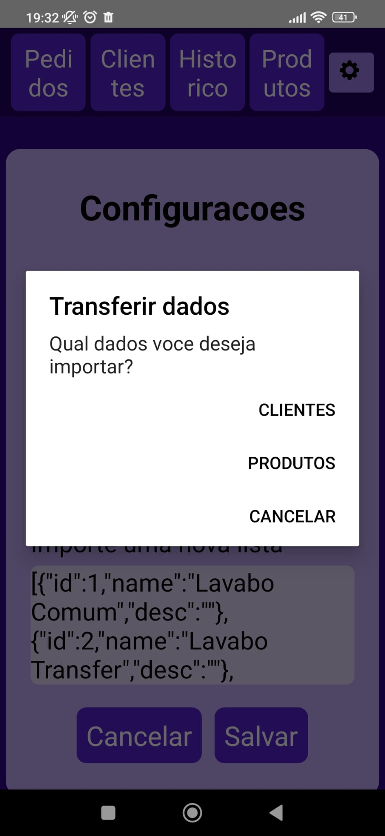

*Note for first-time users: Ensure you import a product list before the client list to avoid assigning non-existent products to clients.

**EXPORT A LIST**

You can export either the **Client** or **Product** list via email for backup purposes.